# Light-dependent Resistor Measurement Experiment

# 

## Introduction

As is known to all, the sound control light in the corridor also have a sensor in addition to the sound control, which is a photosensitive sensor(Photovaristor) also called a photosensitive resistor. It(LDR is the abbreviation for photosensitive resistor) is generally made of cadmium sulfide. While the incident light increase, the resistance decrease, vice versa. Photosensitive resistance is commonly used to measure, control and transform(Light will be converted into electrical energy), it can also be extensive used in various light control circuits, control and adjust the photoswitch.

First of, we conducted an uncomplicated experiment using a photosensitive resistor. Owing to the photosensitive resistor is a component that can be controlled by light intensity, it is naturally necessary to read the analog value via the analog interface. According to the previous PWM interface experiment, we can replace the potentiometer with a photoresistor, and then while the intensity of the light is changed, the brightness of the LED will change accordingly.

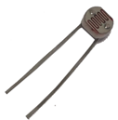 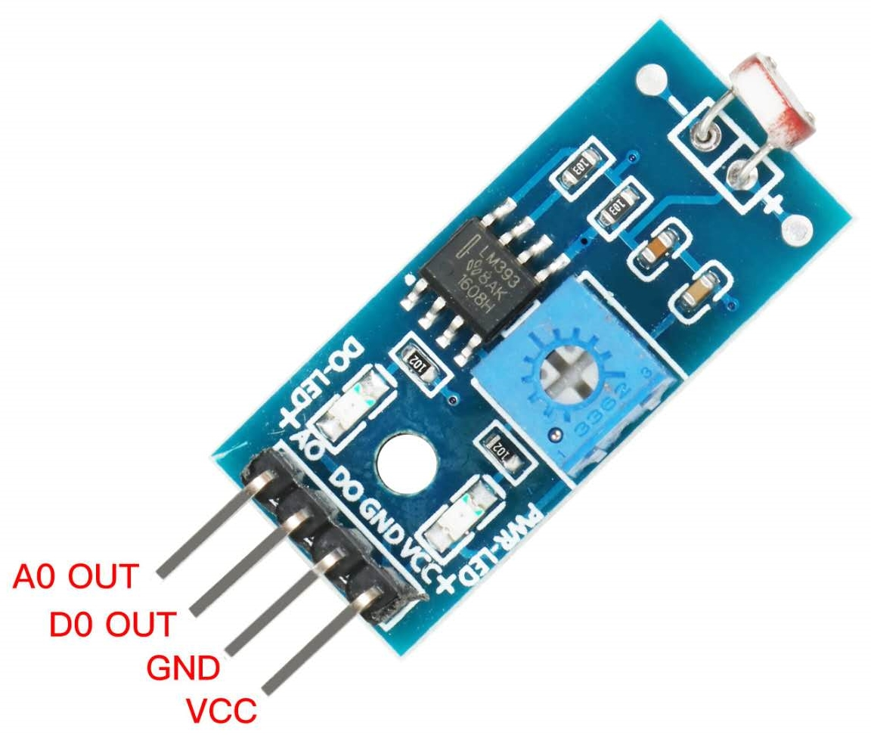

LDR LDR Module

## Component List

* Raspberry Pi main board
* Raspberry Pi expansion board
* Breadboard
* Cable
* LDR *1
* LED *1
* 10kΩ Resistor *1
* 220Ω Resistor *1
* Several jumper wires

## Wiring

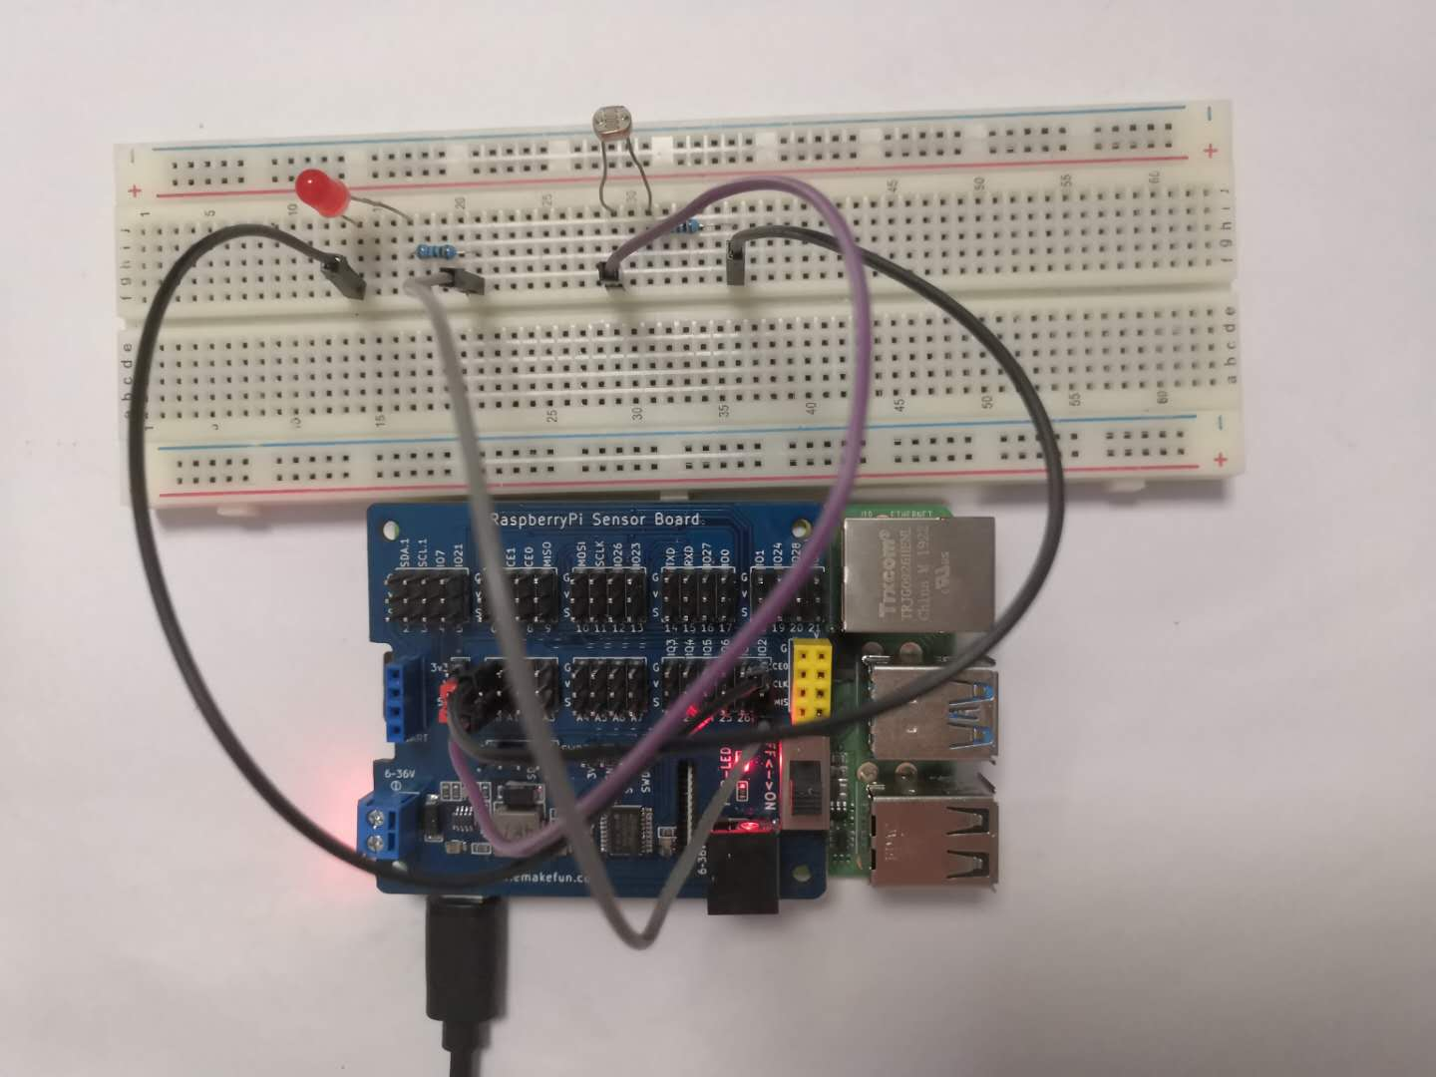

## C++ program

#include <stdio.h>//导入基础库

#include <wiringPi.h>//导入树莓派WiringPi编码IO控制库

#include <wiringPiI2C.h>//导入树莓派WiringPi编码I2C控制库

int LEDPIN **=** 2 **;** //led灯接2口

int value **=** 0 **;**

float voltage **=** 0.0 **;**

int main**()**

**{**

wiringPiSetup**();**

wiringPiI2CSetup**(**0x04**);**

pinMode**(**LEDPIN**,** OUTPUT**);**

**while(**1**)**

**{**

digitalWrite**(**LEDPIN**,** HIGH**);**

value **=** wiringPiI2CReadReg16**(**0x04**,** 0x10**);**

//printf("%d\n",value);

voltage **=** **(** **(** float **)**value **)/**1023 **;** //通过A / D模数转换器获得实际电压

value **=** voltage **\*** 100 **;** //灵敏度为10.0 mV /℃,利用公式计算出 Value 值 **if(**value **>** 0**)**

**{**

digitalWrite**(**LEDPIN**,** HIGH**);**

delay**(**1000**);**

**}** **else** **{**

digitalWrite**(**LEDPIN**,** LOW**);**

**}**

printf**(**"%d\n"**,** value**);** //打印 Value 值

delay**(**400**);**

**}**

**}**

**Python program**

|  |
| --- |
| import time  import smbus as smbus  import RPi**.**GPIO as GPIO  ledpin **=** 27  ADC**=**smbus**.**SMBus**(**1**)**#Declare to use I2C 1  GPIO**.**setmode**(**GPIO**.**BCM**)**  GPIO**.**setup**(**ledpin**,** GPIO**.**OUT**)**    **while** True**:**  ADC**.**write_byte**(**0x04**,** 0x20**)**#Write a byte to the slave  val **=** ADC**.**read_word_data**(**0x04**,** 0x20**);**  temp **=** val **/** 1023 **\*** 5 **\*** 100 //通过A / D模数转换器获得实际电压,利用公式计算出 Value 值 GPIO**.**output**(**ledpin**,** True**)**  time**.**sleep**(**1**)**  **else:**  GPIO**.**output**(**ledpin**,** False**)**  print**(**temp**)**#Raspberry Pi reads the data returned by the expansion board and prints it out  time**.**sleep**(**1**)**#Delay 1 second |

**Java program**

|  |
| --- |
| **import** com**.**pi4j**.**wiringpi**.**I2C**;**  **import** com**.**pi4j**.**wiringpi**.**Gpio**;**  public class Photoresistance **{**  static int led_pin **=** 2**,** value **=** 0**,** fd**;**  static **{**  Gpio**.**wiringPiSetup**();**  fd **=** I2C**.**wiringPiI2CSetup**(**0x04**);**  Gpio**.**pinMode**(**led_pin**,** Gpio**.**OUTPUT**);**  **}**  public static void main**(**String**[]** args**){**  **for** **(** **;** **;){**  value **=** I2C**.**wiringPiI2CReadReg16**(**fd**,** 0x10**);**  **if(**value **>** 1700**)** **{**  Gpio**.**digitalWrite**(**led_pin**,** Gpio**.**HIGH**);**  Gpio**.**delay**(**200**);**  **}** **else** **{**  Gpio**.**digitalWrite**(**led_pin**,** Gpio**.**LOW**);**  **}**  **}**  **}**  **}** |

**Experimental Effect**



We use the Raspberry Pi to control the photosensitive sensor. While the light intensity becomes weak, the LED will be lit. This experiment requires us to understand how the Raspberry Pi reads analog values.